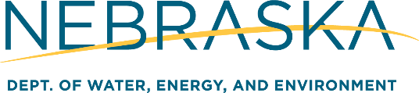
Small Business Compliance Advisory Panel Meeting
September 8, 2026
Nebraska Department of Environment and Energy
Fallbrook Building, 245 Fallbrook Blvd, Room 023
Lincoln, NE 68521
___________________________________

AGENDA

1:30-2:00 Check-in/Welcomes
2:00-2:05 Meeting begins with Open Meetings Act reading
2:05-2:30 Introductions/Welcome and Opening Statements
2:30-3:00 SBCAP Annual Report Review (2025)
3:00-3:15 SBCAP General Discussion
3:15-3:30 NDEE Statewide Outreach Review
3:30-4:00 Additional Items
4:00 Adjourn

