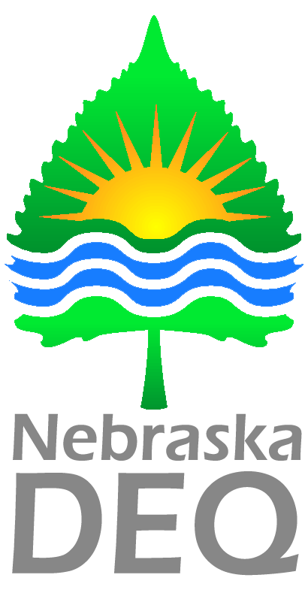
2026

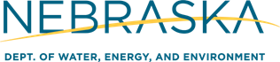

OnBase Air Burn Permits – Technical Guide for Applications

Form #: 07-285

Contents
How to Register for an Account 3
How to Login 6
Portal Home Page 7
Filling Out an Application 9

How to Register for an Account
To start the online permit process, you must first register for an account. Please read all of the steps carefully:

*Images in this guide may not appear exactly as they do on your screen*
- Go to the DWEE portal for registration or click the following link:
https://ecmp.nebraska.gov/DEQ-BRN/Account/Login
You should now be at the DWEE portal
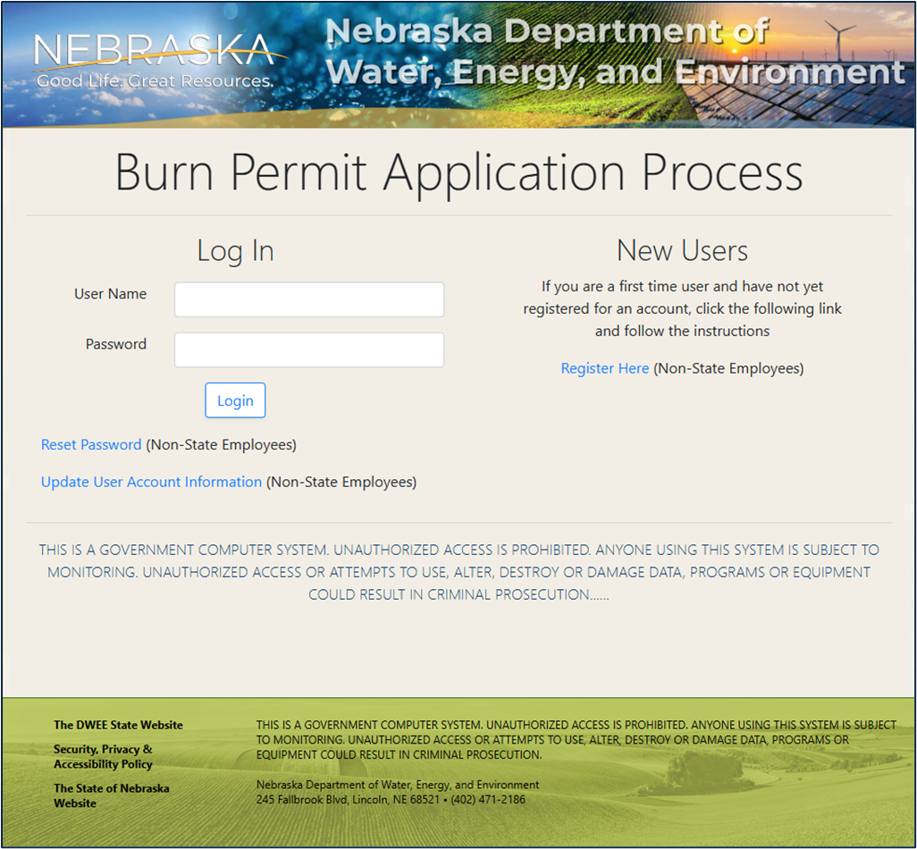

- New Users
  - To create a new account – click on Register Here under NEW USERS on the right side of the screen.
  - If you have a User Name – type in your User Name and Password to verify your authorization to the application.
  - If you need to reset your Password – click on the Reset Password option.
  - If you need to update other account information – click on the Update User Account Information.
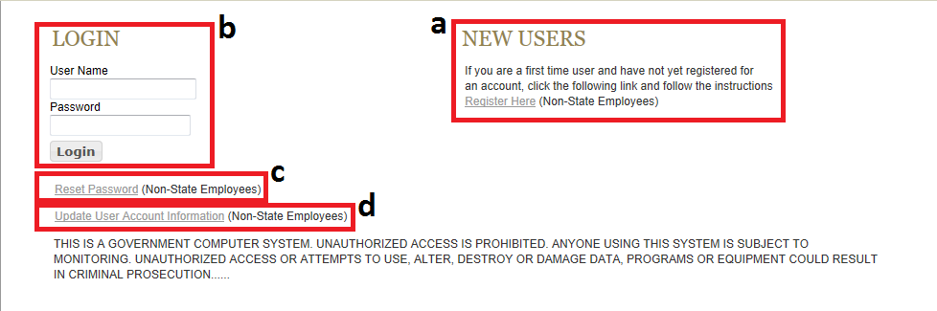

- New Account Registration
After clicking on the Register Here option, you will be at the New Account Registration Page. You will need to complete all of the fields on this page. If you would like to view details on requirements for specific fields such as Username and Password, click the Field Requirements link. The following list will guide you through the fields you will need to complete:
  - First Name – enter your first name
  - Last Name – enter your last name
  - Email Address – enter the email address that will be associated with this account and grant applications
  - Confirm Email – re-enter the email address typed above
  - Username – Create a username for this account (no spaces)
  - Password – Create a password for this account*
PLEASE NOTE: The password must be at least eight characters and contain at least one uppercase letter, one lowercase letter, and one digit with no spaces. Click the Field Requirements or Password Rules link for more information on password requirements.
  - Password Reminder Questions – You must select three password reminder questions and supply an answer for each question. These questions will be used to authenticate your identify if you need to change your password or account information.
    - Select a security question from the drop-down box
    - Type your answer in the Your Answer field. This field is not case sensitive

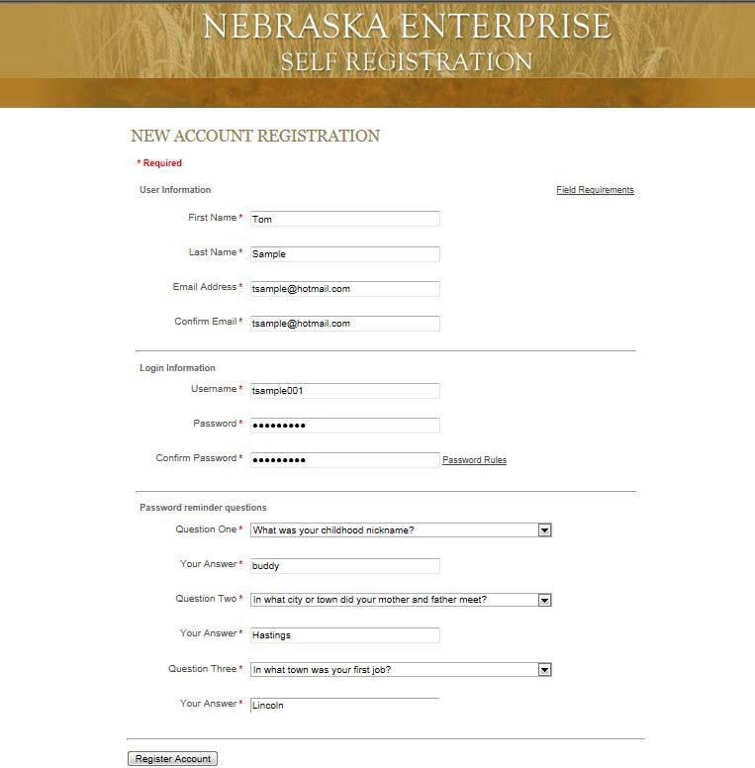

- Prior to completing your registration, please note or record your User Name, Password, Security Questions and Answers. The Help Desk does not have access to this information and cannot reset passwords. This is a user responsibility.
- To complete your registration click the Register Account button.
- After successfully creating an account, a message will appear stating that your account has been created, and that you are being redirected to the sign in page. If you do not see the sign in page within 10 seconds, click the link that says here.
- You will be redirected/returned to the DWEE login page.

How to Login
The following steps only apply to accounts that have been successfully created. If you have not yet successfully created an account, please refer to the previous section: How to Register for an Account.

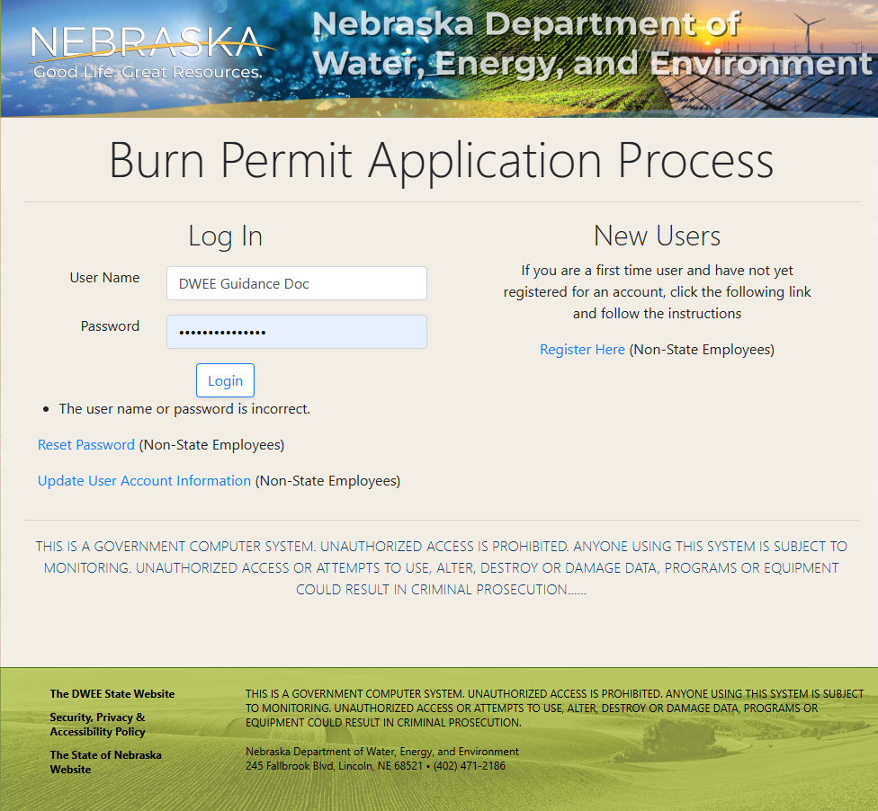
- To access the application open your internet browser and go to: https://ecmp.nebraska.gov/DEQ-BRN/Account/Login

- In the second field, enter your User Name (this will automatically display in all caps)
- Enter your Password
- Click on the Login button
You should now be logged into the portal. Please refer to the next section “Portal Home Page”.

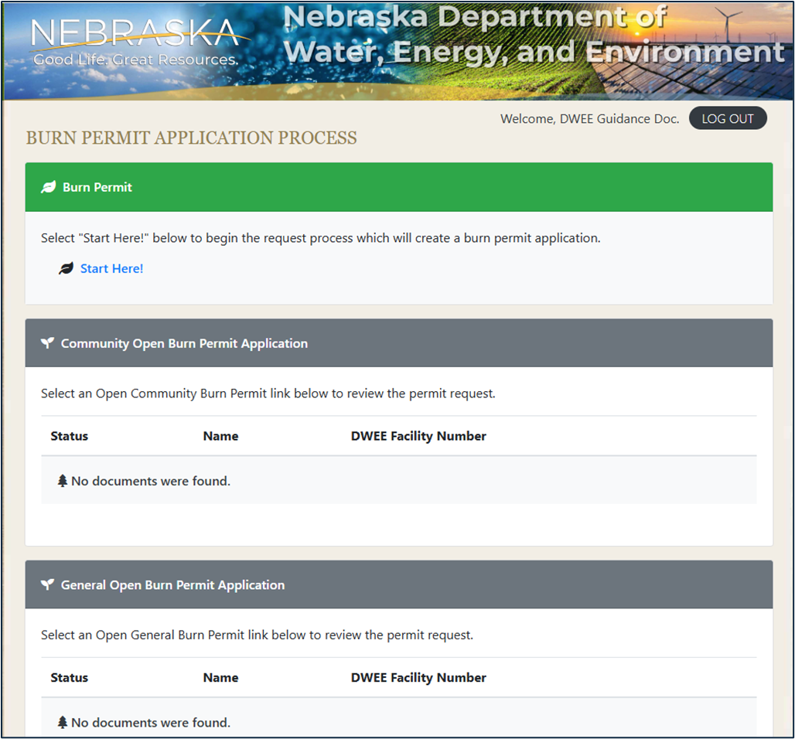
Portal Home Page
3
2
1
- Create new applications
- Access previously created and saved Community Burn Permit Applications or Community Burn Permit Applications that were sent back for modification. (Applications are only saved for 30 days)
- Access previously created and saved General Open Burn Permit Applications or General Open Burn Permit Applications that were sent back for modification. (Applications are only saved for 30 days)

- List of completed applications with current status

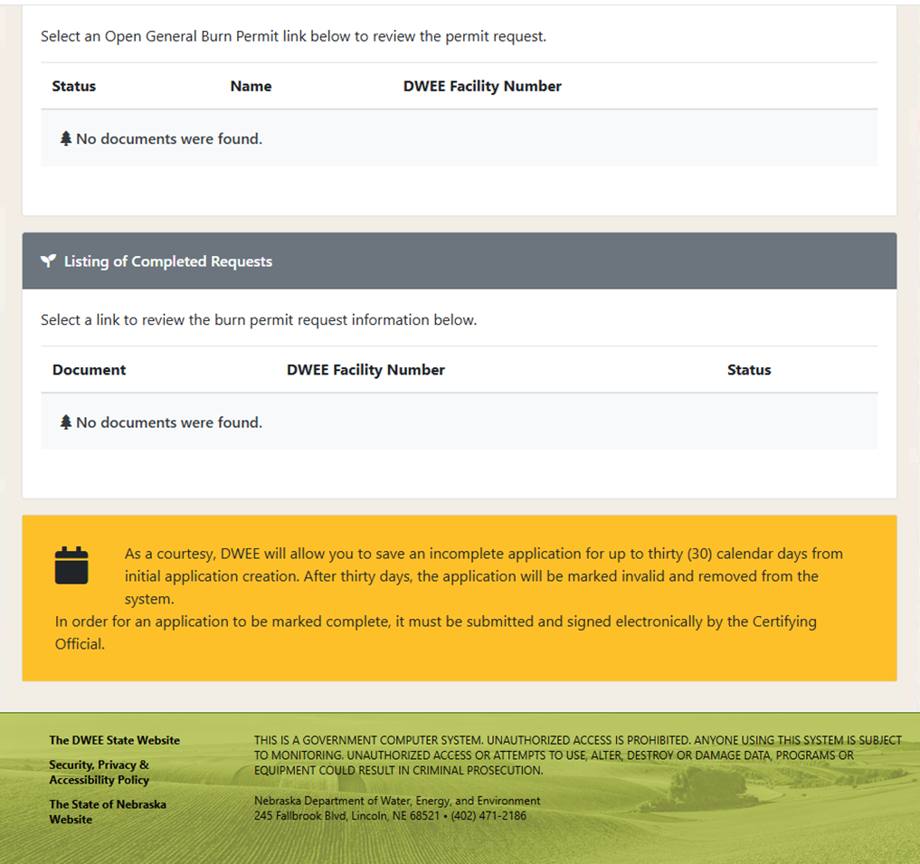
43

Filling Out an Application
After starting a new application you will be asked a series of questions to determine the permit type needed and eligibility. (Images and questions may vary from the examples depending on the permit type applying for and how questions are answered)
- Select the desired permit type:

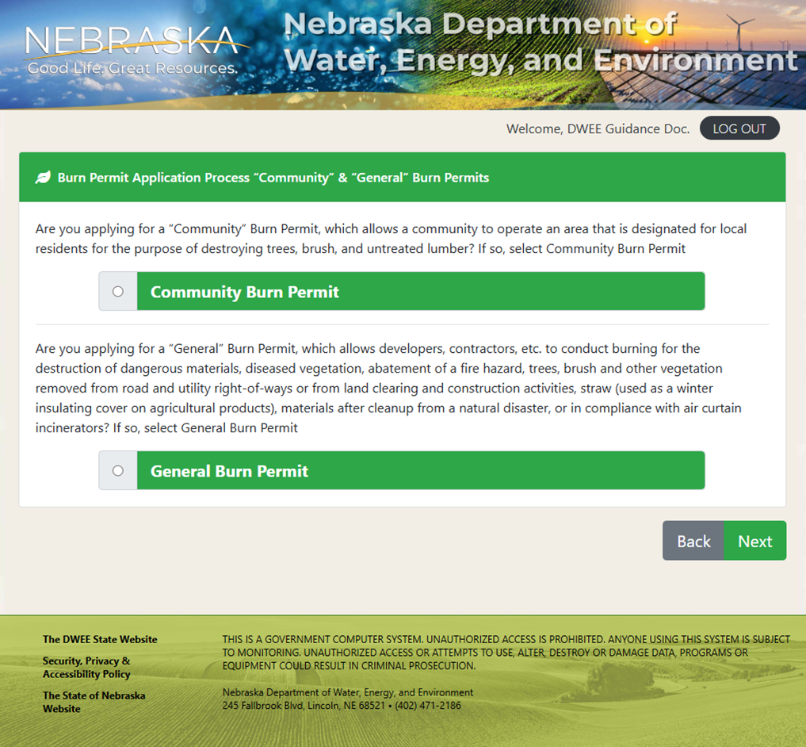
- Answer the qualifying questions to determine if you are eligible for a Burn Permit (Qualifying questions will vary depending on the type of permit you are applying for):

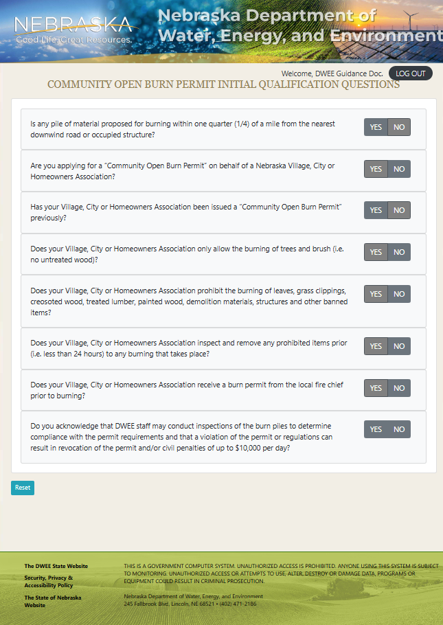
- If eligible to apply for a permit, you will see a screen similar to the following where you will fill out the application. Fields marked with an * or highlighted in red are required fields:

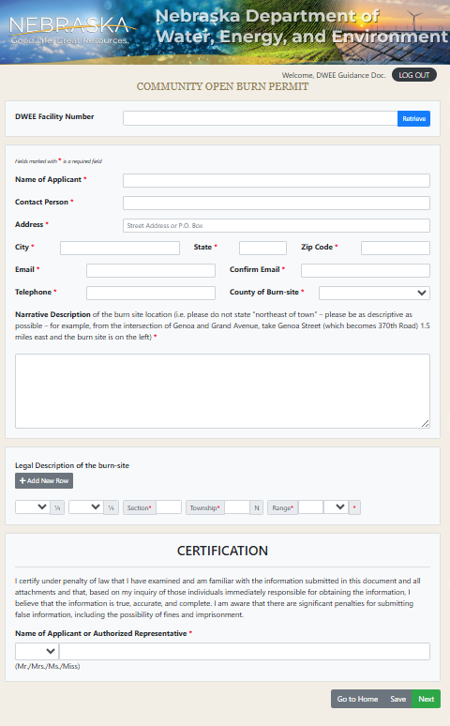
- Upload Supporting Documents, if applicable:

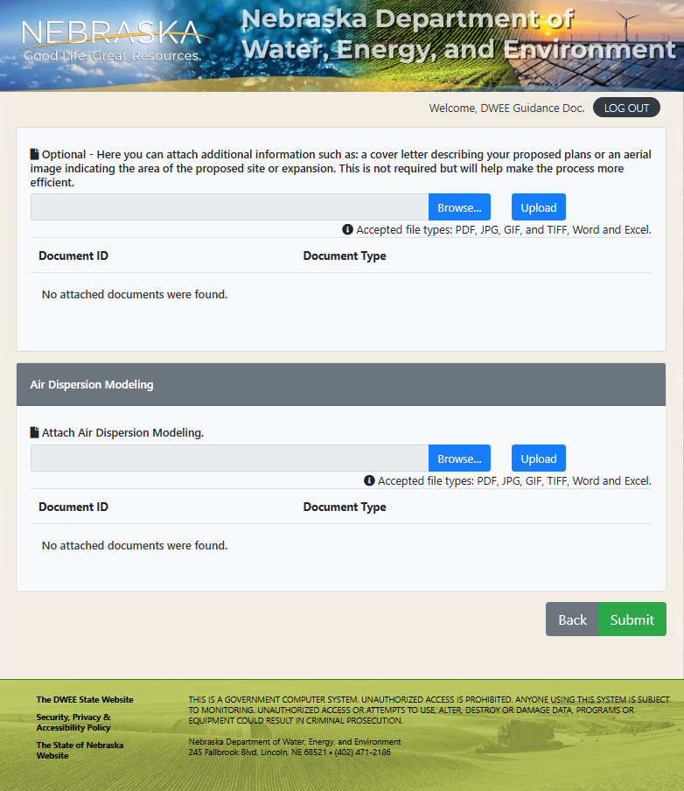
3
1 2

  - Click Browse to locate the desired document
  - After selecting the document click Upload to upload the document
  - When finished click Submit to submit your application for review

- If submitted successfully you should receive the following message stating that the application has been submitted for review. It may take up to 24 hours for DWEE to receive the application after it is submitted.

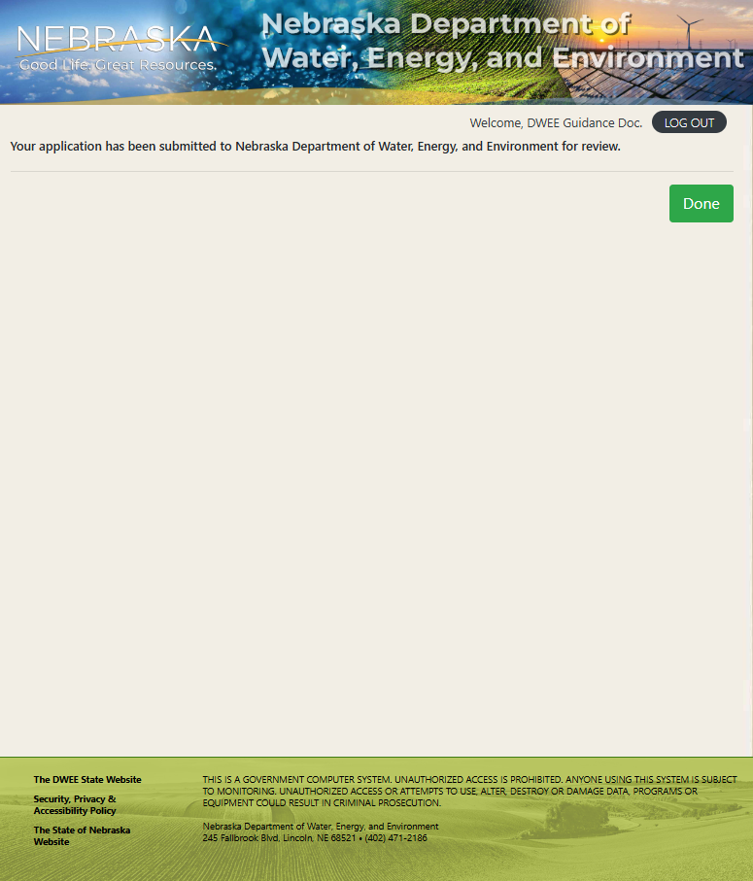

If you have any questions while filling out your application, or questions regarding Nebraska’s air quality regulations regarding community burn permits or general fire permits, please contact us at our DWEE Air Quality email address:

DWEE.AirQuality@nebraska.gov

