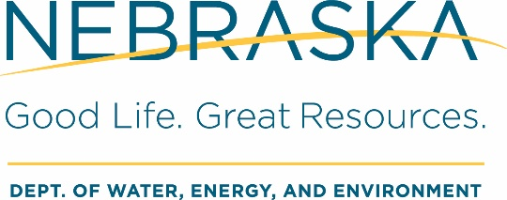
Submit completed form to:
Drinking Water and Water Wells Division
245 Fallbrook Blvd., Ste. 100, Lincoln, NE 68521
Phone: 402.471.2186 Fax: 402.471.2909
dwee.ecmupload@nebraska.gov

Non-Transient Non-Community
Public Water Supply System
Capacity Development Statement of Intent

I, [Owner Name], intend to own [System Name], a new non-transient non-community public water supply system, for the foreseeable future.

☐ Yes ☐ No

If you checked ‘No’ above, please provide the new owner contact information below:
Name: [Name]
Address: [Address]
Phone: [Phone] Email: [Email]

This facility plans to meet the minimum technical, managerial, and financial capacity requirements of a new community public water system with the following operating budget. The mandatory first year is provided. Available projections for years two through five are also provided.

Proposed Operating Budget for the
Non-Transient Non-Community Water Supply System

Operating Budget Information | Year 1 | Year 2 | Year 3 | Year 4 | Year 5
I. Income
Revenues
- Reserve Accounts
- Budget Surplus
- Financing Sources
Total Income
II. Expenses
- Water System Operating Expenses, including Capital Improvements
- All Other Operating Expenses
Total Expenses
Income Less Expense

